High School U.S. Government Classroom  The Founding Documents: Shaping America  VIDEO VIEWING GUIDE | 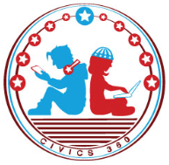  Name: ______________  Date: _______________

Question | List Specific Evidence  from the Video | Complete Sentence
1.What is self-governance?

2. What is the Mayflower Compact?

3. What was the purpose of Common Sense?
4. What are three ideas contained in Common Sense?
5. Who authored the Declaration of Independence?
6. What did the Declaration of Independence establish within the closing paragraph?
7. What is the purpose of this political cartoon?
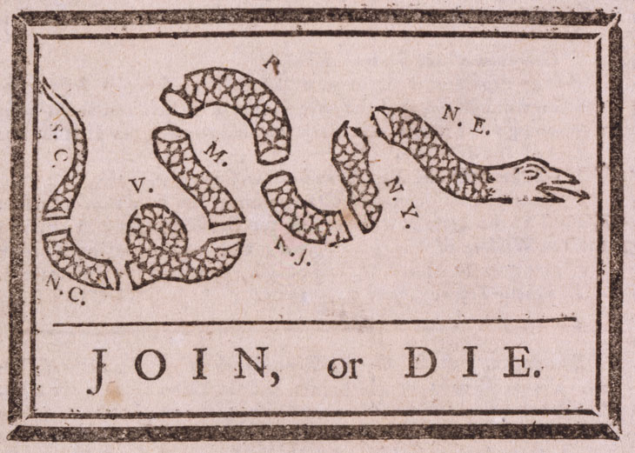
8. From which document did Thomas Jefferson incorporate ideas into the Declaration of Independence?
9. Which of Common Sense’s ideas did Thomas Jefferson incorporate into the Declaration of Independence?
10. What was the purpose of the Mayflower Compact?
11. What type of government was created under the Articles of Confederation?
12. What connection can be made between the Articles of Confederation and the Declaration of Independence?
13. What were some of the weaknesses of the Articles of Confederation?

14. What type of government was created under the U.S. Constitution?
15. What core governmental theme remained the same between the Articles of Confederation and the U.S. Constitution?
16. How does the U.S. Constitution emphasize self- governance?

