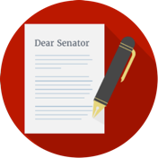 | Influencing the Government  Interest Groups & the Media
- I can identify ways interest groups monitor and/or influence the government.
- I can identify ways the media monitors and/or influences the government

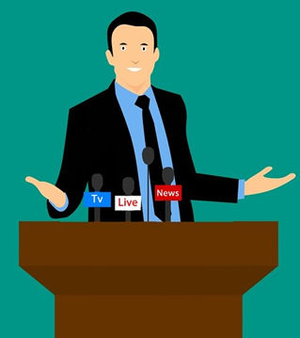
Interest groups use their First Amendment rights to peaceable assembly, free speech, and petition to monitor and influence the government. Interest groups are groups that form because of a common goal. They attempt to influence people by working together for their goal.

Political Action Committees (PAC) are often connected to interest groups. A PAC can raise money and contribute to the campaigns of candidates that they support. Interest groups can work with members of Congress or with other elected legislators to get laws passed. This is usually referred to as lobbying.

An interest group can also educate its members on issues it wants the group members to support. For example, interest groups ask their members to vote and give money to candidates that the interest group supports.

Examples of Interest Groups
Organization | Logo | Their Mission
American Civil Liberties Union (ACLU) | https://www.aclu.org | defend and preserve the individual rights and liberties guaranteed to every person in this country by the Constitution and laws of the United States
Mothers Against Drunk Driving (MADD) | https://www.madd.org | end drunk driving, help fight drugged driving, support the victims of these violent crimes, and prevent underage drinking
National Rifle Association (NRA) | https://home.nra.org | protect and defend the Constitution of the United States, especially … [the] right of the individual American citizen ... to acquire, possess, collect, exhibit, transport, carry, transfer ownership of, and enjoy the right to use arms
The Humane Society | https://www.humanesociety.org | educate policymakers and the public about animal abuse and promote kind treatment of animals

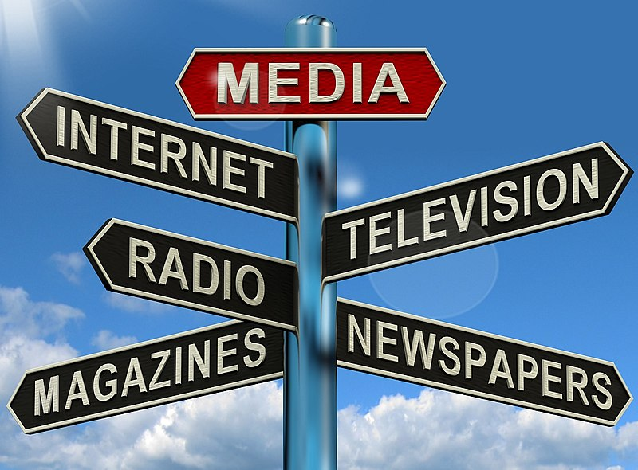
The Media
The First Amendment protects freedom of the press. The media uses this right to monitor and influence the government. The media report stories about public officials, give information online about the government, or broadcast news reports on the radio or TV. The media plays an important role in both monitoring and influencing the government through their reporting.

