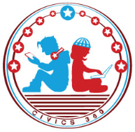
The Founding: SS.7.CG.1.3
Influential Documents
VIDEO VIEWING GUIDE #2
Name: ________________________________

Date: _________________________________
The Mayflower Compact & Common Sense Video #2
Question | List Specific Evidence from the Video | Complete Sentence
1. What was the Mayflower Compact?
2. What is meant by ‘self-government’?

3. What did the English settlers want from a government?
4. Define the term ‘social contract’.
5. Summarize the important ideas that are in the Mayflower Compact.
6. How did the Mayflower Compact influence American ideas on government?
7. Summarize the important ideas that are in Common Sense.
8. How did Common Sense influence the writing of the Declaration of Independence?
9. Summarize how American ideas about government were influenced by Common Sense.

Extra Notes Section

