FL State & Local Government: SS.7.C.3.13
Comparing Constitutions
VOCABULARY PRACTICE
Name: ______________________

Date: _______________________
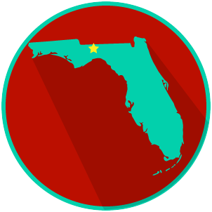
Comparing Constitutions

Write about your understanding of the purpose of a constitution by explaining the connections between and among each of the terms in the concept circle.

How do the terms in the concept circle fit together?

