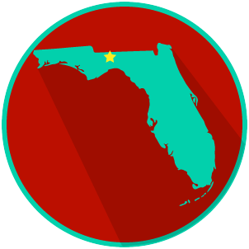
FL State & Local Government:
SS.7.C.3.13
Comparing Constitutions
READING GUIDE #2
Name: ______________________

Date: _______________________

Reading: Structure of the U.S. and Florida Constitutions

Benchmark Clarification 2: Students will recognize the basic outline of the U.S. and Florida constitutions (both have articles, amendments, and preambles).

Reading Task | Response
What ideas are presented in the reading? (use other side if necessary)
What is the central idea of the reading?
Select two words or phrases that support the central idea.
How might this reading connect to your own experience or something you have seen, read, or learned before?
Describe three ways the U.S. and Florida Constitutions are the same, and three ways they are different. | Similarities  1.
 | 2.
 | 3.
Differences
1.
 | 2.
 | 3.

