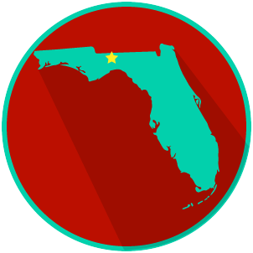
FL State & Local Government:
SS.7.C.3.13
Comparing Constitutions
READING GUIDE #3
Name: ______________________

Date: _______________________

Reading: Comparing Amendment Processes

Benchmark Clarification 3: Students will compare the amendment process of the U.S. and Florida constitutions.

Reading Task | Response
What ideas are presented in the reading?
What is the central idea of the reading?
Select two words or phrases that support the central idea.
How might this reading connect to your own experience or something you have seen, read, or learned before?
Which constitution is probably more difficult to amend, the Florida or U.S., and why? | The most difficult constitution to amend is probably the __________________________________________ because:

