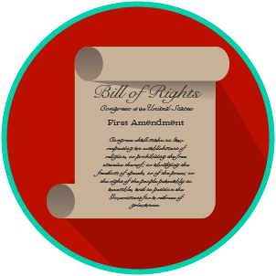
My Rights & Liberties: SS.7.CG.2.4
Protecting and Limiting Rights
VIDEO VIEWING GUIDE #1
Name: ________________________________

Date: _________________________________
Protecting Our Rights Video #1
Question | List Specific Evidence from the Video | Complete Sentence
1. Why didn’t the Founding Fathers believe the Constitution needed a Bill of Rights?

2. What rights will we find in Article I, Section Nine of the U.S. Constitution?

3. Explain the concept of habeas corpus
4. How does banning ex post facto law protect our rights?
5. What is eminent domain and how is connected to the Fifth Amendment?
6. What rights in the First Amendment support civil disobedience?
7. How are citizen property rights and right to protest protected?
8. Why did the Founding Fathers create an independent judiciary?

9. What does Article III of the U.S. Constitution cover?
10. What is the appellate process?
11. How does an independent judiciary safeguard our rights?
12. How does the Constitution protect (safeguard) our rights outside of the Bill of Rights?

Extra Notes Section

