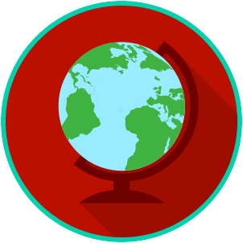
The U.S. and the World: SS.7.CG.4.2
International Organizations
READING #1
Name: ________________________

Date: _________________________

SS.7.CG.4.2 Benchmark Clarification 1: Students will identify major international organizations in which government plays a role (e.g., North Atlantic Treaty Organization, United Nations, International Court of Justice, World Trade Organization).

World War II and the Holocaust brought more attention to issues and problems around the world. People paid more attention to human rights (the rights that people have simply because they exist). Different organizations were created to help with these issues and problems. Many governments all over the world created and participated in international organizations that protected human rights and focused on economic issues.
Below are some examples of major international organizations in which many governments participate.
Name of Organization | Short Form Name | Symbol | Purpose
North Atlantic Treaty Organization | NATO | 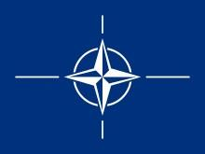 | A group of 28 countries that have agreed to protect each other in case of attack; they formed NATO to protect themselves against the Soviet Union and its communist allies.  It is a military and defense agreement among the governments of member nations.
United Nations | UN | 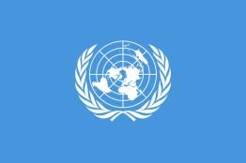 | Created to keep peace around the world and develop friendly relationships among nations. There are 193 nations (governments) that are members of the United Nations.
International Court of Justice (World Court) | No short form name. | 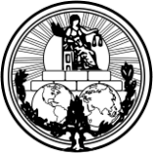 | The World Court gives legal advice to the UN and deals with international legal issues, such as a disagreement about borders between countries.  Countries may become members by meeting the requirements of the UN. Individuals may work or intern with the World Court.
World Trade Organization | WTO | 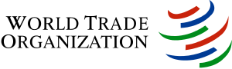 | The WTO was created to promote trade and economic growth by lowering taxes and removing limits on some types of trade. Countries may join and make agreements about trade and taxes.

