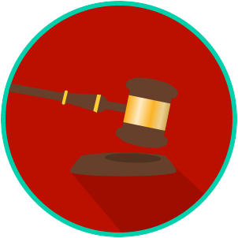
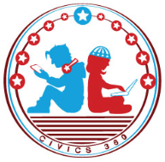
The Legal System: SS.7.CG.3.9
State & Federal Courts
VIDEO VIEWING GUIDE #1
Name: ________________________________

Date: _________________________________

State Courts Video #1
Question | List Specific Evidence from the Video | Complete Sentence
1. What is jurisdiction?

2. What are the four levels of the court system in Florida?
3. What is an appellate court?
4. If you want to sue someone for $15,000, to which level of the Florida court system would you bring your case?
5. Explain why a plaintiff or a defendant cannot win a trial within a District Court of Appeal?

