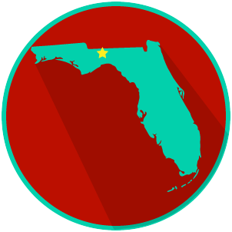
FL State & Local Government:
SS.7.C.3.8/C.3.9
Structure, Powers & Processes of State & Local Government
READING GUIDE #4
Name: ______________________

Date: _______________________

Reading: Lawmaking Process in Local, State, and Federal Government

Benchmark Clarification 4: Students will compare and contrast the lawmaking process at the local, state, and federal levels.

Reading Task | Response
What ideas are presented in the reading?
What is the central idea of the reading?
Select two words or phrases that support the central idea.
How might this reading connect to your own experience or something you have seen, read, or learned before?
Which lawmaking process you studied do you think has the most impact on your daily life, and why? | The lawmaking process I studied that has the most impact of my daily life is the lawmaking done at the _________________________ level.  It has the most impact on me because:

