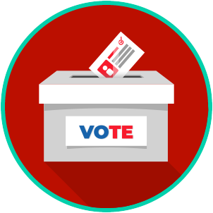
Voting and Elections: SS.7.CG.2.6
Election Processes
READING GUIDE #1

Name: ____________________

Date: _____________________
Reading: Elections and Voting

Benchmark Clarification 1: Students will explain how elections and voting impact citizens at the local, state, and national levels.

Reading Task | Response
What ideas are presented in the reading?
What is the central idea of the reading?
Select two words or phrases that support the central idea.
How might this reading connect to your own experience or something you have seen, read, or learned before?
Explain how citizens are involved in voting at the local, state, and national levels.

