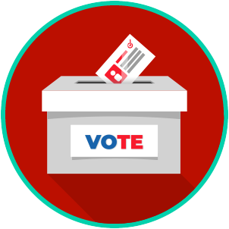
Voting and Elections: SS.7.CG.2.6
Election Processes
READING GUIDE #2
Name: ____________________

Date: _____________________
Reading: Elections and Voting

Benchmark Clarification 2: Students will explain the origins of the Republican and Democratic political parties and evaluate their roles in shaping public policy.

Reading Task | Response
What ideas are presented in the reading?
What is the central idea of the reading?
Select two words or phrases that support the central idea.
How might this reading connect to your own experience or something you have seen, read, or learned before?
Explain the origins of the Republican and Democratic political parties. | The origins of the Republican and Democratic political parties are:

