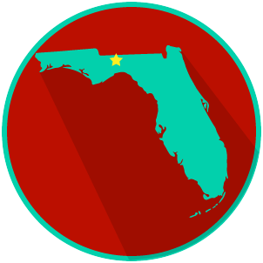
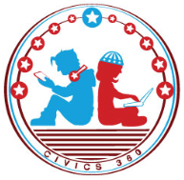
FL State & Local Government: SS.7.CG.3.7
Structure, Powers & Processes
of State & Local Government
VIDEO VIEWING GUIDE #2
Name: ______________________________

Date: _______________________________

Local Government Video #2
Question | List Specific Evidence from the Video | Complete Sentence
1. What are local governments?

2. What are the terms for lawmakers at the city and county level?

3. What is an ordinance?
4. Describe the process for creating laws at the local level.

