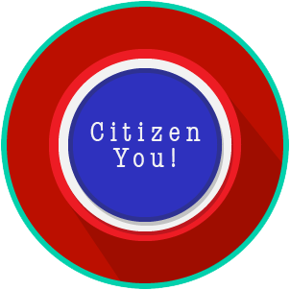
Name: _______________________

Date: ________________________
Citizen You: SS.7.C.2.2, C.2.3 & C.2.14
Citizen Obligations &
Responsibilities
READING GUIDE #3

Reading: Active Participation in Society

Benchmark Clarification 3: Students will evaluate the obligations and/or responsibilities of citizens as they relate to active participation in society and government.

Reading Task | Response
What ideas are presented in the reading?
What is the central idea of the reading?
Select two words or phrases that support the central idea.
How might this reading connect to your own experience or something you have seen, read, or learned before?
In what ways do obligations and/or responsibilities of citizens relate to active participation in society and government? | Ways in which the obligations and/or responsibilities of citizens relate to active participation in society and government are:

