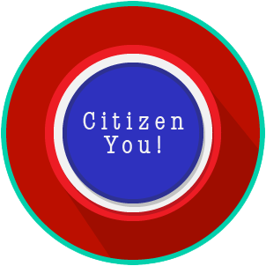
Citizen You: SS.7.C.2.2, C.2.3 & C.2.14
Citizen Obligations &
Responsibilities
READING GUIDE #5
Name: _______________________

Date: ________________________

Reading: Citizen Obligation Scenarios

Benchmark Clarification 5: Students will use scenarios to assess specific obligations of citizens.

Reading Task | Response
What ideas are presented in the reading?
What is the central idea of the reading?
Select two words or phrases that support the central idea.
How might this reading connect to your own experience or something you have seen, read, or learned before?
Create a scenario of your own that shows a specific obligation of citizens.

