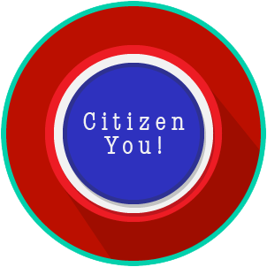
Citizen You: SS.7.C.2.2, C.2.3 & C.2.14
Citizen Obligations &
Responsibilities
READING GUIDE #6
Name: _______________________

Date: ________________________

Reading: Consequences of Disconnected Citizens

Benchmark Clarification 6: Students will identify the consequences or predict the outcome on society of citizens who do not fulfill their citizenship responsibilities.

Reading Task | Response
What ideas are presented in the reading?
What is the central idea of the reading?
Select two words or phrases that support the central idea.
How might this reading connect to your own experience or something you have seen, read, or learned before?
Describe what you think could happen if citizens stop fulfilling their responsibilities. | If citizens stop fulfilling their responsibilities, I think that:

