The Three Branches of Government

- I can understand the processes of the three branches of government.

The United States government is made up of three separate branches. Each branch is organized very differently, has different jobs and responsibilities, and has its own unique set of powers.

Branch | Job | Visual
The Legislative Branch | Makes Laws | 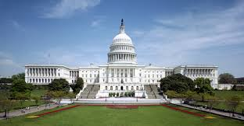  This is the U.S. Capitol Building, where both houses of Congress work.
The Executive Branch | Enforces Laws | 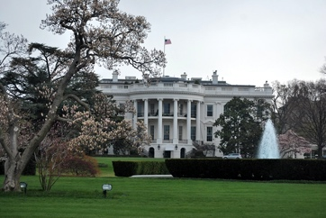  This is the White House where the President lives and works.
The Judicial Branch | Interprets Laws | 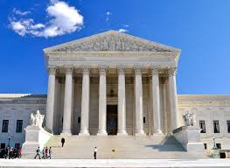  This is the Supreme Court building, the highest court in the United States.

Separation of Powers
Each branch of government has its own unique, specific, and separate jobs that only that branch of government can do. This system is known as separation of powers. Separation of powers was included in the Constitution by the Founding Fathers, so that no branch of government could become too powerful. This was originally an idea of Montesquieu and was a safeguard to make sure no one was too powerful like King George III of England was when the United States was the original thirteen colonies.

The Legislative Branch
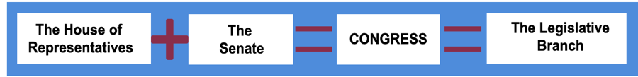
The legislative branch, also called Congress, is the combination of the House of Representatives and the Senate. The legislative branch is also called Congress at the federal level of government. Congress' job is to create laws. Creating laws is a long and difficult process that must be followed by members of Congress, also known as legislators (lawmakers). Their main job is to make laws that are meant to serve, protect, and keep order for the citizens of the United States.

The Executive Branch
The executive branch is led by the president. It is the job of this branch to put into place and enforce laws. This branch is composed of many different departments and people who make sure laws are being followed by everyone. Here are some examples of how laws are enforced by the executive branch:

How Laws are Enforced
Department of the Treasury | One of the 15 main departments in the executive branch that makes up the president’s cabinet (the president’s advisors). This department is responsible for the finances and economy of the nation. This department enforces finance and tax laws.
Department of Agriculture | This is another department that is part of the president’s cabinet. The Department of Agriculture makes sure laws and rules related to farming, agriculture, and food are followed.
Internal Revenue Service (IRS) | This agency makes sure the citizens of the U.S. are paying their taxes.

The Judicial Branch
The judicial branch is made up of all the courts in the United States. From the Supreme Court to all other lower courts. This branch interprets or explains what the laws mean. The judicial branch has the power of judicial review. This means that the judicial branch can review the actions of the executive and legislative branches and determine whether or not they are in line with the Constitution. This includes laws passed by Congress and state laws. The Supreme Court case Marbury v. Madison (1803) established this power.

Examples of Judicial Review
Brown v. Board of Education (1954) | The U.S. Supreme Court ruled that state laws establishing separate public schools for black and white students violated the Equal Protection Clause of the Fourteenth (14th) Amendment.
Loving v. Virginia (1967) | A state law that made interracial marriage illegal was overturned by the Supreme Court because it violated the Constitution’s Equal Protection and Due Process Clauses in the Fourteenth (14th) Amendment.

Checks and Balances
Checks and balances were included in the Constitution to make sure one branch wouldn’t control too much power. Each branch has the ability to ‘check’ the actions of the other two branches. Let’s look at a few examples:
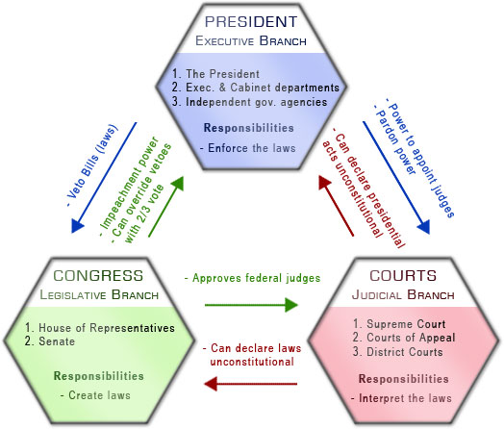
- The President nominates a Supreme Court justice, but the Senate approves or denies the appointment.
- A law is created by Congress, the president can veto the law.
- Congress can override a veto by the president.
- The Supreme Court can declare laws written by Congress unconstitutional.
- The president can send a treaty to the Senate, but the Senate has the power to formally approve, ratify, the treaty.

