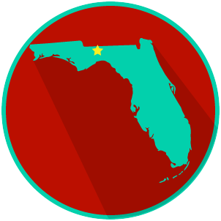
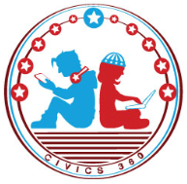
FL State & Local Government: SS.7.CG.3.7
Structure, Powers & Processes
of State & Local Government
VIDEO VIEWING GUIDE #1
Name: ______________________________

Date: _______________________________

State Government Video #1
Question | List Specific Evidence from the Video | Complete Sentence
1. What is the state law making body called?

2. How is the Florida Legislature Structured?

3. What are members of the Florida House of Representatives and the Florida Senate called?
4. What is the term for state laws passed by the Florida State Legislature?
5. What is a proposed law called?

6. Describe the lawmaking process as you have learned it so far.
7. Add to your description of the state lawmaking process to complete the steps.

Extra Notes Section

