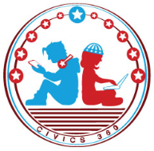
The Legal System: SS.7.CG.3.9
State & Federal Courts
VIDEO VIEWING GUIDE #2
Name: ________________________________

Date: _________________________________

Federal Courts Video #2
Question | List Specific Evidence from the Video | Complete Sentence
1. Which section of the U.S. Constitution outlines the federal court system?

2. What are the three levels of the federal court system?
3. Your friend tells you that she just found out her case will be heard by the U.S. Supreme Court. What kind of question would your friend’s case involve?
4. What are three of the eight kinds of cases federal courts hear?
5. Why can’t a jury ever find anyone guilty of a crime within a U.S. Court of Appeals?

