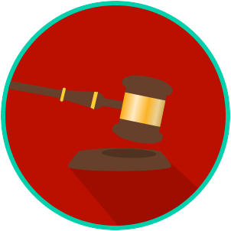
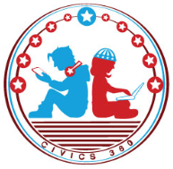
The Legal System: SS.7.C.2.6
The Trial Process and Juries Civil Trials
VIDEO VIEWING GUIDE
Name: ________________________________

Date: _________________________________

Question | List Specific Evidence from the Video | Complete Sentence
1. What type of law is civil law?

2. What is another term for a civil case?
3. Explain the difference between the plaintiff and the defendant.
4. Summarize the four steps of the civil trial process

