FL State & Local Government: SS.7.C.3.8/C.3.9
Structure, Powers & Processes of State & Local Government
VOCABULARY PRACTICE
Name: ______________________

Date: _______________________
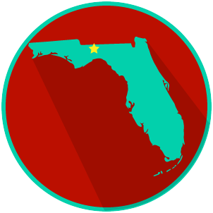

Structure, Powers & Processes of State & Local Government

Write about your understanding of the state and local law-making process by explaining the connections between and among each of the terms in the concept circle.

How do the terms in the concept circle fit together?

