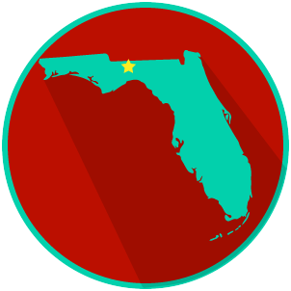
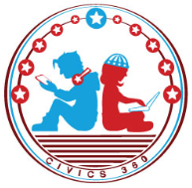
FL State & Local Government: SS.7.C.3.8/C.3.9
Structure, Powers & Processes
of State & Local Government
VIDEO VIEWING GUIDE #1
Name: ______________________________

Date: _______________________________

State Government Video #1
Question | List Specific Evidence from the Video | Complete Sentence
1. What is the state law making body called?

2. How is the Florida Legislature Structured?

3. What are members of the Florida House of Representatives and the Florida Senate called?
4. What is the term for state laws passed by the Florida State Legislature?
5. What is a proposed law called?

6. Describe the lawmaking process as you have learned it so far.
7. Add to your description of the state lawmaking process to complete the steps.

Extra Notes Section

FL State & Local Government: SS.7.C.3.8/C.3.9
Structure, Powers & Processes
of State & Local Government
VIDEO VIEWING GUIDE #2
Name: ______________________________

Date: _______________________________

Local Government Video #2
Question | List Specific Evidence from the Video | Complete Sentence
1. What are local governments?

2. What are the terms for lawmakers at the city and county level?

3. What is an ordinance?
4. Describe the process for creating laws at the local level.

FL State & Local Government:
SS.7.C.3.8/C.3.9
Structure, Powers & Processes of State & Local Government
READING GUIDE #1
Name: ______________________

Date: _______________________

Reading: The Processes of the Three Branches of Government

Benchmark Clarification 1: Students will examine the processes of the legislative (e.g., how a bill becomes a law, appointment confirmation, committee selection), executive (e.g., executive order, veto, appointments), and judicial (e.g., judicial review, court order, writ of certiorari, summary judgment) branches of government.

Reading Task | Response
What ideas are presented in the reading?
What is the central idea of the reading?
Select two words or phrases that support the central idea.
How might this reading connect to your own experience or something you have seen, read, or learned before?
Summarize the processes of ONE of the branches of government you read about, in your own words.

FL State & Local Government:
SS.7.C.3.8/C.3.9
Structure, Powers & Processes of State & Local Government
READING GUIDE #2
Name: ______________________

Date: _______________________

Reading: Comparing Local, State, and Federal Lawmakers

Benchmark Clarification 2: Students will compare local, state, and federal lawmakers (city/county commissioners/council members; state legislators [representatives and senators]; and U.S. congressmen/congresswomen [representatives and senators]).

Reading Task | Response
What ideas are presented in the reading?
What is the central idea of the reading?
Select two words or phrases that support the central idea.
How might this reading connect to your own experience or something you have seen, read, or learned before?
How are lawmakers the same and different at the local, state, and federal level? | Lawmakers are same at the local, state, and federal level because they:
 | Lawmakers are different at the local, state, and federal level because they:

FL State & Local Government:
SS.7.C.3.8/C.3.9
Structure, Powers & Processes of State & Local Government
READING GUIDE #3
Name: ______________________

Date: _______________________

Reading: Ordinances, Statutes, and Acts

Benchmark Clarification 3: Students will distinguish among ordinances, statutes, and acts on the local, state, and federal levels.

Reading Task | Response
What ideas are presented in the reading?
What is the central idea of the reading?
Select two words or phrases that support the central idea.
How might this reading connect to your own experience or something you have seen, read, or learned before?
What is the difference between ordinances, statutes and acts?

FL State & Local Government:
SS.7.C.3.8/C.3.9
Structure, Powers & Processes of State & Local Government
READING GUIDE #4
Name: ______________________

Date: _______________________

Reading: Lawmaking Process in Local, State, and Federal Government

Benchmark Clarification 4: Students will compare and contrast the lawmaking process at the local, state, and federal levels.

Reading Task | Response
What ideas are presented in the reading?
What is the central idea of the reading?
Select two words or phrases that support the central idea.
How might this reading connect to your own experience or something you have seen, read, or learned before?
Which lawmaking process you studied do you think has the most impact on your daily life, and why? | The lawmaking process I studied that has the most impact of my daily life is the lawmaking done at the _________________________ level.  It has the most impact on me because:

FL State & Local Government: SS.7.C.3.8/C.3.9
Structure, Powers & Processes of State & Local Government
VOCABULARY PRACTICE
Name: ______________________

Date: _______________________

Structure, Powers & Processes of State & Local Government

Write about your understanding of the state and local law-making process by explaining the connections between and among each of the terms in the concept circle.

How do the terms in the concept circle fit together?

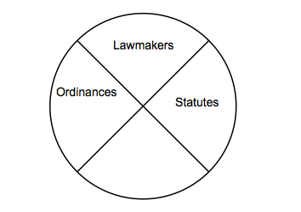

FL State & Local Government SS.7.C.3.8/C.3.9
Structure, Powers & Processes of State & Local Government
PRACTICE QUIZ
Name: _______________________

Date: ________________________

Structure, Powers & Processes of State & Local Government Practice Quiz Reflection

FIRST Attempt Score | I answered ______ questions right.
One thing I learned:

SECOND Attempt Score | I answered ______ questions right.
One thing I learned:

