Weaknesses of the Articles of Confederation

- I can identify the weaknesses of the Articles of Confederation.

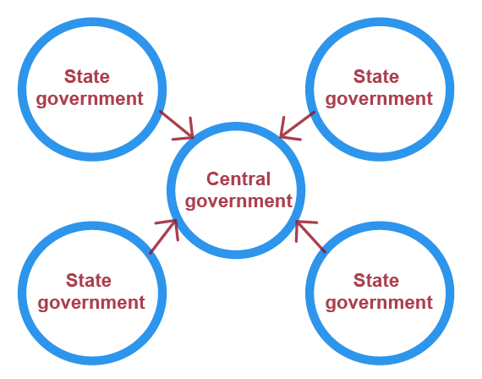
After the colonists declared independence from Great Britain, they needed to create a system of government for their new and independent nation. The nation’s first government was established through the Articles of Confederation.

The Articles of Confederation set up a confederal system. This means that government power was located with the states and there was little power at the central, or national, level of government. Since the Articles of Confederation created a system with little central power, each state operated almost as an independent country. It became difficult for the national government to govern and many elements of the Articles of Confederation became weaknesses.
Under the Articles of Confederation, Congress DID NOT have the power to:
Raise Money
Regulate Trade
Enforce Laws

After the Revolutionary War, the United States was in debt, owing a lot of money from the war. Not being able to collect money from the states was a huge weakness. Without taxes collected by Congress, the U.S. could not pay for an Army or Navy or pay back other countries that supported the United States during the war.

Another weakness with the Articles of Confederation was that Congress did not have the power to regulate, or control, trade with other countries. But, states could tax goods, or products, going from one state to the other state. Under the Articles of Confederation, all of the government power at the national level was with the legislative branch. This was a huge problem because it meant that Congress could not actually enforce any laws that they passed.
Under the Articles of Confederation, there was NONE of the following:
Central Executive Leadership
Central Court System

Under the Articles of Confederation, there was no mention of an executive or judicial branch. There was no central leadership or executive branch to make sure that laws were being enforced in each state. Since there was no central court system, or judicial branch, there was nobody to interpret laws or settle disputes between states.

Under the Articles of Confederation
ALL 13 states had to agree to make changes.
You might be able to relate to another important weakness of the Articles of Confederation. Imagine trying to get all of your friends, some who might not like each other, to agree to do something. It isn’t easy, is it?

Well, there was a similar problem under the Articles of Confederation. Just like you might have a hard time to get all of your friends to agree to do something, it was very hard to get all 13 states to agree to make amendments, or changes, to the Articles of Confederation. They had to be unanimous, or all agree, to make changes to make things better.

