Responsibilities and Obligations of Citizens
Reading One
- I can distinguish between citizen obligations and duties.

The United States defines the term citizen in the Fourteenth (14th) Amendment of the Constitution as someone who is born or naturalized in the United States. In the United States, citizens are guaranteed protection of their natural rights. Natural rights are rights a citizen is born with that cannot be taken away by the government. These natural rights are the right to life, liberty and the pursuit of happiness. Being a U.S. citizen means that there are both obligations and responsibilities that must be met to support our representative democracy and to make sure that citizens’ rights are protected.

Obligations and responsibilities contribute to the common good. The common good is actions or beliefs that benefit everyone in a community. Obligations, also known as duties, are things that we HAVE to do or we could face legal consequences, such as fines or jail time. Responsibilities are things we SHOULD do so that our communities are nice places to live. Unlike obligations, there are no legal consequences if responsibilities are not done.

OBLIGATIONS of CITIZENS
Obligations of citizens are things that citizens are required to do to ensure that the United States continues to be a better and safer place. They are required by law and have some legal consequence for not doing them. Some examples of obligations are: paying taxes, registering for Selective Service, and serving on juries. Let’s explore each of these obligations.

We will begin with taxes, because everyone pays taxes! Taxes are money given to the government by the people. For example, when people shop or eat at restaurants they pay sales tax and when they work they pay income tax.

So, how can taxes make America a better and safer place? They help the government afford services that benefit the general public, such as Medicare, Social Security, roads, and even your school!
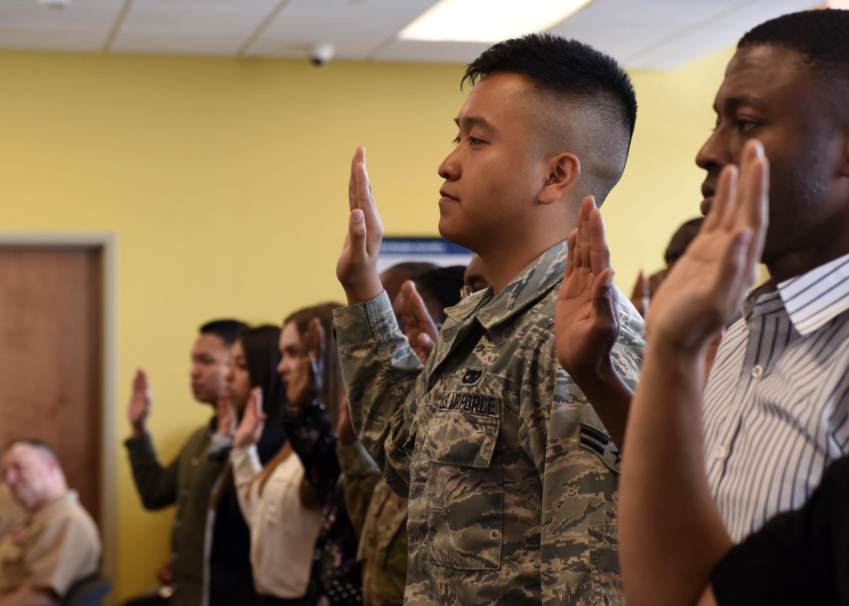
What about the Selective Service? Just what IS the Selective Service? All male citizens and non-citizens, between the ages of 18-25 years old are required to register with the Selective Service, an agency of the federal government that maintains information on those who may be subject to a draft to defend the country.

So, why is the Selective Service obligation important? When you register for Selective Service, the government knows where to find you just in case there is a military draft. The draft requires you to join the military if more troops are needed to defend the country. By defending the nation, citizens make sure that those who are living in the United States are protected from any potential enemies.

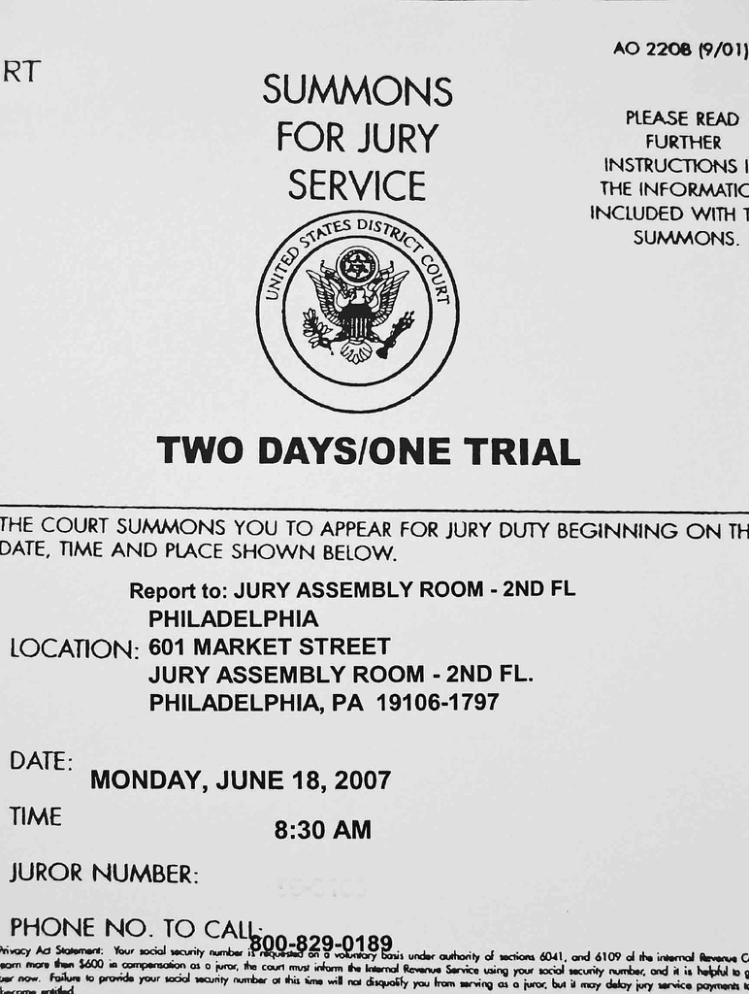
We’ve got paying taxes and registering for Selective Service, but what about jury duty? Sometimes people make jokes about jury duty and why they don’t want to do it, but what is jury duty and why is it such an important obligation for citizens?

Serving on a jury during a trial means you are a part of the group who decides the outcome of a trial. The Bill of Rights guarantees the right to a jury trial. And if we don’t have people that can serve on a jury, or are willing to serve on a jury, then how can we ensure that the right to a jury trial is protected? This is one of the most important obligations we have as citizens.

RESPONSIBILITIES of CITIZENS

A responsibility is an action that citizens do for the common good. So we can think of the responsibilities of citizens as something you do not have to do, but something you should do as a citizen. In our government system, it is both the government and the citizens that are responsible for protecting our rights and promoting the common good. Responsibilities are all about the common good, doing things to benefit the community, and not just ourselves. Some responsibilities of citizens include voting, attending public meetings, volunteering, and petitioning the government.

Why is voting an important responsibility? Remember as citizens, it is important that we actively engage with our community and voting allows citizens to decide on leaders that reflect their own beliefs and values.

Other responsibilities of citizenship are also about being engaged in our communities. Attending civic meetings, petitioning the government, and volunteering are ways that citizens can be engaged. It benefits everyone when citizens see a community need and take steps to find a solution. It is all about being responsible citizens in our communities and our country.

So, why do responsibilities matter if there is no law that says we have to do them? Imagine what your community would be like if no one actually cared! Fulfilling our responsibilities as citizens helps our communities become a better place to live!

