Federal Government: SS.7.CG.1.9 Limits on Government Power
Name:

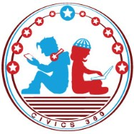
Date:

VIDEO TWO VIEWING GUIDE

Question | List Specific Evidence from the Video | Complete Sentence
1. What is the purpose of limited government?
2. What are individual rights and what protects them?
3. What are two ways that the Constitution protects individual rights?
4. List three individual rights protected by our Bill of Rights.
5. Where is due process
mentioned in the Bill of Rights?
6. What is due process?
7. What is the rule of law?

1
Civics360 ©Lou Frey Institute 2017 All Rights Reserved Florida Joint Center for Citizenship

