STUDENTS INVESTIGATING PRIMARY SOURCES

Decoding the Declaration
What did declaring independence say about the importance of rights?
A Short Activity for High School

Benchmark Correlations
Celebrate Freedom Week Information
SS.912.C.1.2-Explain how the Declaration of Independence reflected the political principles of popular sovereignty, social contract, natural rights, and individual rights.
Benchmark Clarifications: Students will identify and explain rights specified in the Declaration of Independence (i.e., natural rights, popular sovereignty, social contract).
Students will identify and describe popular sovereignty, social contract, natural rights, and individual rights.
LAFS.910.RH.1.2- Determine the central ideas or information of a primary or secondary source; provide an accurate summary of how key events or ideas develop over the course of the text.
LAFS.1112.RH.1.2-Determine the central ideas or information of a primary or secondary source; provide an accurate summary that makes clear the relationships among the key details and ideas.

Activity Documents and Handouts
- Projected image of the Dunlap Broadside of the Declaration of Independence
- Excerpted text from the Declaration of Independence
- Decoding the Declaration Graphic Organizer

Full Document Citations
Dunlap Broadside [Declaration of Independence], July 4, 1776; Rough Journals, 9/5/1774 - 3/2/1789; Records of the Continental and Confederation Congresses and the Constitutional Convention, 1765 - 1821, Record Group 360; National Archives Building, Washington DC. National Archives Identifier: 301682.
[https://catalog.archives.gov/id/301682] [https://www.docsteach.org/documents/document/dunlap-broadside]
Engrossed Declaration of Independence, August 2, 1776; Miscellaneous Papers of the Continental Congress, 1774 - 1789; Records of the Continental and Confederation Congresses and the Constitutional Convention, 1765 - 1821, Record Group 360; National Archives Building, Washington, DC. National Archives Identifier: 1419123.
[https://catalog.archives.gov/id/1419123] [https://www.docsteach.org/documents/document/the-declaration-of-independence]

Activity Vocabulary
endowed – given or provided
liberty – freedom, an individual’s right to be free
self-evident – clear or obvious
unalienable – cannot be taken away or denied

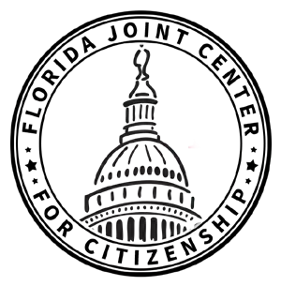

- Project the Dunlap Broadside of the Declaration of Independence and then project the excerpted text from the transcript on Page 5.
- Ask students if they can identify the document based on the image and text they have viewed. Lead students to the understanding that they are looking at the Declaration of Independence of the United States of America.
- Ask students the following question: What did declaring independence say about the importance of rights?
- Pass out the Decoding the Declaration graphic organizer and explain to students that they will analyze a piece of text from the preamble, or introduction, of the Declaration of Independence to understand the relationship between the document and rights. Teacher Note: Be sure to explain to students that preamble of the Declaration of Independence focuses on individual rights.
- Explain to students that you will model how to analyze the text by reading it aloud, thinking aloud and modeling a possible answer for the column labeled “What I think it means”. Teacher Note: Utilize the Sample Answers to guide this step.
- Instruct students to follow along while you model the first section of the text.
- Explain to students that it is now their turn to analyze the rest of the text from the Declaration of Independence. Teacher Note: Students can be divided in a number of ways: individually, in pairs, or in groups. If students need more guidance before moving from direct instruction, support students by having them work in pairs.
- Provide time for students to complete the rest of the graphic organizer. Circulate through the classroom to monitor understanding.
- Bring students back together as a whole class.
- Review each piece of text and have students share out what they think it means. After students share their ideas, use the completed graphic organizer to guide students to understand what the text really means.
- Direct students to the question at the bottom of the graphic organizer and provide students with time to answer the question independently.
Enrichment Suggestion #1 – Instruct students to answer the following questions in writing: How does this statement from the Declaration of Independence relate to United States government today? What does this statement mean to you?
Enrichment Suggestion #2 – Have students use DocsTeach to find images to create a photo collage of images that symbolize the words from the text they studied. On the back of the collage, instruct students to explain why they selected each image and how it connects to the words.
Enrichment Suggestion #3 – Show students an example of a dramatic reading of the Declaration of Independence. (For example, show this celebrity reading from DeclareYourself on SchoolTube. The dramatic reading starts at 4:35.) Have students work in pairs or in a small group to create and perform their own dramatic reading.

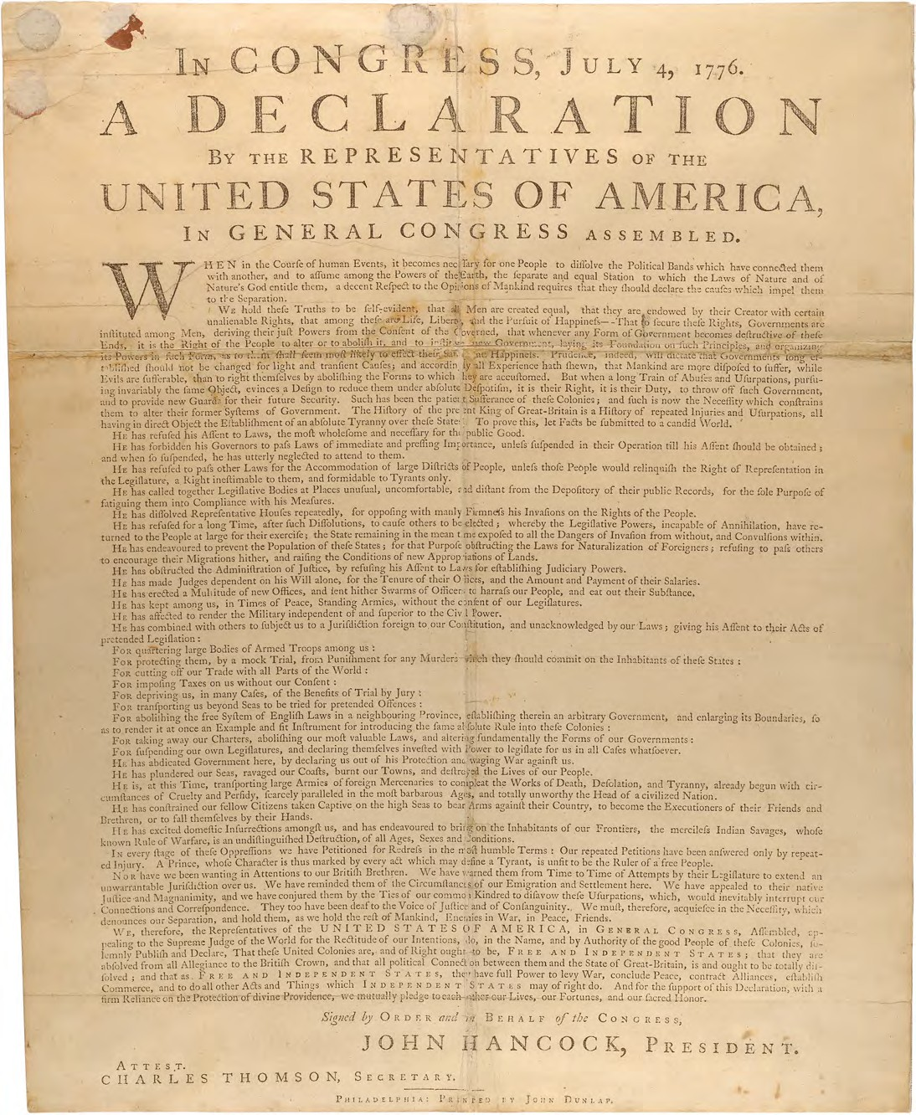

“We hold these truths to be self-evident, that all men are created equal, that they are endowed by their Creator with certain unalienable Rights, that among these are Life, Liberty and the pursuit of Happiness.”

Name:

Decoding the Declaration
Date:

VOCABULARY
endowed – given or provided
liberty – freedom, an individual’s right to be free
self-evident – clear or obvious
unalienable – cannot be taken away or denied

Text | What I think it says | What it really means
We hold these truths to be self-evident,
that all men are created equal,
that they are endowed by their Creator with certain unalienable Rights,
that among these are Life, Liberty and the pursuit of Happiness.

Guiding Question: What did declaring independence say about the importance of rights?

