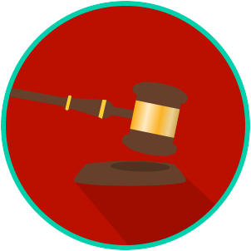
The Legal System: SS.7.C.3.11/C.2.6
State & Federal Courts
VOCABULARY PRACTICE
Name: _____________________

Date: ______________________
State and Federal Courts

Write about your understanding of the levels, functions, and powers of courts by explaining the connections between and among each of the terms in the concept circle.

How do the terms in the concept circle fit together?

