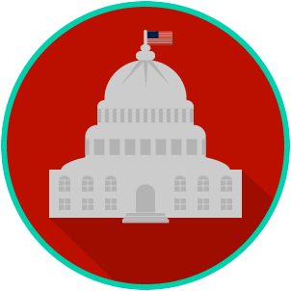
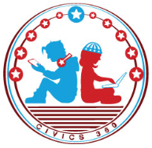
Federal Government: SS.7.C.1.6
Preamble of the U.S. Constitution
VIDEO VIEWING GUIDE
Name: ________________________________

Date: _________________________________

Question | List Specific Evidence from the Video | Complete Sentence
1.What is the purpose of the U.S. Constitution?

2. What is the purpose of the Preamble to the U.S. Constitution?

3. Why might the phrase ‘We the People’ be so large?
4. Explain the phrase ‘form a more perfect union’.
5. Explain the phrase ‘establish justice’.

6. What does the term ‘justice’ mean?

7. What part of our government works to ensure that we establish justice?

8. What does the term ‘domestic’ refer to?

9. What does the term ‘tranquility’ mean?
10. Explain the phrase ‘insure domestic tranquility’.

11. Based on what you have learned so far, what do we mean when we say something is ‘common to a community’?

For example, ‘The park is for common use.’
12. Explain the phrase ‘provide for the common defence’.

13. Based on what you have learned so far, when you care about someone’s welfare, what are you caring about?
For example, if someone says to you ‘I was concerned about your welfare and wanted to make sure you were okay.’
14. Explain the phrase ‘promote the general welfare’.

15. What does the term ‘liberty’ refer to?

16. If you are concerned about your posterity, what are you concerned about?
For example, ‘My grandparents often say that they are proud of their posterity when they see what good jobs their grandkids have.’
17. Explain the phrase ‘secure the blessings of liberty for ourselves and our posterity.’

Name: ________________________

Date: _________________________
Federal Government: SS.7.C.1.6
Preamble of the U.S. Constitution
READING GUIDE #1
Reading: The Preamble: An Introduction to the Constitution

Benchmark Clarification 1: Students will explain how the Preamble serves as an introduction to the U.S. Constitution, establishing the goals and purposes of government.

Reading Task | Response
What ideas are presented in the reading?
What is the central idea of the reading?
Select two words or phrases that support the central idea.
How might this reading connect to your own experience or something you have seen, read, or learned before?
In what way does the Preamble introduce the U.S. Constitution? | The Preamble introduces the U.S. Constitution by:

Name: ________________________

Date: _________________________
Federal Government: SS.7.C.1.6
Preamble of the U.S. Constitution
READING GUIDE #2
Reading: Goals and Purposes of Government

Benchmark Clarification 2: Students will identify the goals and purposes of government as set forth in the Preamble of the U.S. Constitution (i.e., form a more perfect union, establish justice, ensure domestic tranquility, provide for the common defense, promote the general welfare, and secure the blessings of liberty to ourselves and our posterity).

Reading Task | Response
What ideas are presented in the reading?
What is the central idea of the reading?
Select two words or phrases that support the central idea.
How might this reading connect to your own experience or something you have seen, read, or learned before?
What are the goals and purposes of government as set forth in the Preamble to the U.S. Constitution? | The goals and purposes of government as set forth in the Preamble are:

Name: ________________________

Date: _________________________
Federal Government: SS.7.C.1.6
Preamble of the U.S. Constitution
READING GUIDE #3
Reading: Understanding “We the People”

Benchmark Clarification 3: Students will recognize that the intention of the phrase “We the People” means that government depends on the people for its power and exists to serve them.

Reading Task | Response
What ideas are presented in the reading?
What is the central idea of the reading?
Select two words or phrases that support the central idea.
How might this reading connect to your own experience or something you have seen, read, or learned before?
What does the phrase ‘We the People’ mean? | The phrase ‘We the People’ means:

Name: ________________________

Date: _________________________
Federal Government: SS.7.C.1.6
Preamble of the U.S. Constitution
VOCABULARY PRACTICE
Preamble of the U.S. Constitution

Write about your understanding of the intentions of the Preamble by explaining the connections between and among each of the terms in the concept circle.

How do the terms in the concept circle fit together?

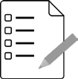
Federal Government: SS.7.C.1.6
Preamble of the U.S. Constitution
PRACTICE QUIZ
Name: ________________________

Date: _________________________
Preamble of the U.S. Constitution Practice Quiz Reflection

FIRST Attempt Score | I answered ______ questions right.
One thing I learned:

SECOND Attempt Score | I answered ______ questions right.
One thing I learned:

