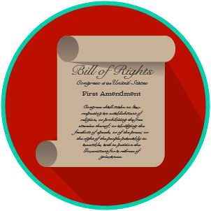
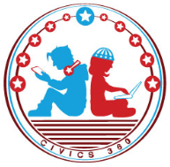
My Rights & Liberties: SS.7.CG.2.4
Protecting and Limiting Rights
VIDEO VIEWING GUIDE #2
Name: ________________________________

Date: _________________________________
Limits on Rights Video #2
Question | List Specific Evidence from the Video | Complete Sentence
1. How does the Constitution protect (safeguard) our rights outside of the Bill of Rights?

2. Why might individuals not be able to use their freedoms as much as they like?

3. What are the rights in the First Amendment?
4. What do courts and the government have to balance when it comes to our rights?
5. If we are at war, why might there be limits on free speech?

6. If there is a riot or national disaster, why might your right to assemble be limited?
7. Why can’t you shout ‘fire’ in a crowded theater if there is no fire?
8. How might your right to property be limited?
9. When might the government require citizens to ration food?
10. What might cause habeas corpus to be limited?
11. What was forced internment during World War II?
12. Why might our rights be limited?
13. Provide an example that reflects each of the following standards that the courts use to determine whether a right can be limited:
13a. Clear and Present Danger
13b. Fighting Words
13c. Libel
13d. Conflict with government interests:
14. What must the courts ask when determining whether rights can be limited?

