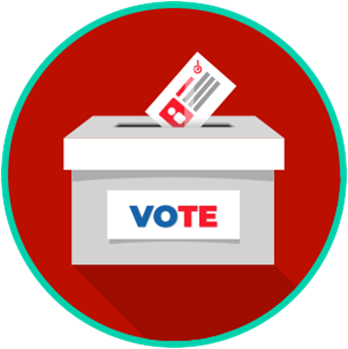
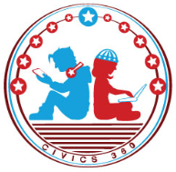
Voting and Elections: SS.7.CG.2.6
The Election and Voting Process
VIDEO VIEWING GUIDE
Name: ________________________________

Date: _________________________________
Elections and Voting
Question | List Specific Evidence from the Video | Complete Sentence
1. What did the colonists mean by ‘no taxation without representation’?

2. What acts passed by Parliament limited the rights of colonists after the Boston Tea Party?

3. What positions do citizens vote for in national elections?
4. What positions do citizens vote for in Florida state elections?
5. What positions do people vote for in local elections?
6. What is the first thing citizens must do in order to be able to vote?
7. What are two reasons why voter registration is important?
8. What does it mean when you register as ‘No Party Affiliation’?
9. What is the purpose of a primary election?
10. What is different between a primary election and a general election?
11. What is the difference between an open primary and a closed primary? Which model is used in Florida?
12. How are elections an example of federalism?
13. What is meant by the term ‘candidate’?
14. What is a basic definition of a political party?
15. Why is it important to have competing political parties in an election?
16. What are the ways in which elections can impact citizens at the national level?

17.How can elections at the state and local levels impact citizens?

18. What must all citizens know and understand for elections to be truly free and fair?

19. Describe the connection between free and fair elections and the consent of the governed.

