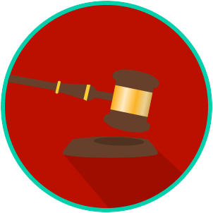
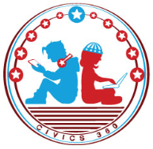
The Legal System: SS.7.CG.3.9
State & Federal Courts
VIDEO VIEWING GUIDE #3
Name: ________________________________

Date: _________________________________

Powers of State and Federal Courts Video #3
Question | List Specific Evidence from the Video | Complete Sentence
1. Where are the powers and jurisdictions of the Florida court system described?

2. What is the name of the highest court in Florida?
3. Where does the federal court system get its powers and jurisdictions?
4. What is the name of the highest court in the United States?

