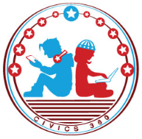
Federal Government: SS.7.CG.3.8
Structure, Powers & Processes of the Executive Branch
VIDEO VIEWING GUIDE
Name: ________________________________

Date: _________________________________

Executive Branch Overview Video
Question | List Specific Evidence from the Video | Complete Sentence
1. Where will we find information about the executive branch?
2. What is the structure of the executive branch?

3. According to the Constitution, what is the main job of the executive branch?
4. What is an executive order?
5. What options does Congress have if they don’t like a president’s executive order?
6. What are the 3 options a president has concerning a bill sent to him by Congress?

7. What role does the president play in the lawmaking process?

8. What are some of the government positions appointed by the President?
9. Which house of Congress has the responsibility of approving appointments?
10. What are three powers of the President discussed in this video?
11. What are two ways that the power of the president can be checked by Congress?

