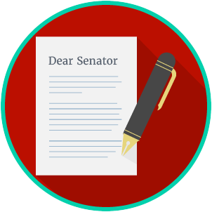
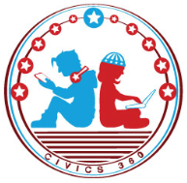
Engaged Citizens: SS.7.CG.2.10
Public Policy
Problem Solving
VIDEO VIEWING GUIDE
Name: ________________________________

Date: _________________________________

Question | List Specific Evidence from the Video | Complete Sentence
1. What are public policies?

2. What kind of problems would local governments try to solve?

3. What kind of problems would state governments try to solve?
4. What kind of problems would the federal governments try to solve?
5. Why do lawmakers look at several possible solutions before choosing the one that will solve a problem?

6. What is a public agency?
7. Based on what you have learned, what is the role of government agencies in solving public problems?
8. Based on what you have learned, describe your own example of a public a policy problem and the level of government that might solve it.

