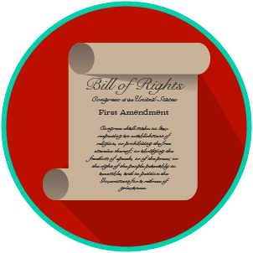
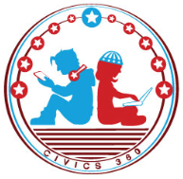
My Rights & Liberties: SS.7.C.3.6
Constitutional Rights and Their Impact
VIDEO VIEWING GUIDE #1
Name: ________________________________

Date: _________________________________

Constitutional Rights Video #1
Question | List Specific Evidence from the Video | Complete Sentence
1. What are constitutional rights?

2. Which documents protect constitutional rights in the United States?

3. What rights and freedoms are contained in the First Amendment?
4. What do we mean when we say our First Amendment rights are both political and social?
5. The Fourth, Fifth, and Fourteenth Amendments all protect citizens from abuse of power by the government.

How do the Fourth and Fifth differ from the Fourteenth?
6. What are three constitutional rights or protections of citizens?

7. What is due process?

8. What are our property rights as protected by the Constitution?

9. In what circumstance might the government be able to take your private property?
10. What is the restriction the government has if it wants to take your property for the public good?
11. Give an example of how the Constitution protects individual rights.

