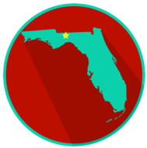
Florida State and Local Government: SS.7.CG.3.12
Comparing Constitutions
READING #4
Name: ________________________

Date: _________________________

SS.7.CG.3.12 Benchmark Clarification 4: Students will recognize the U.S. Constitution as the supreme law of the land.

Article VI (6) of the U.S. Constitution contains the Supremacy Clause, which says that the U.S. Constitution is the “supreme law of the land.” That means that no law is above the U.S. Constitution. If a local or state law conflicts with a national law, the local or state law is struck down, and the national law remains in place.

Supremacy Clause - the clause that states that the U.S. Constitution is the supreme law of the land, and that national laws are supreme over state laws, found in Article VI (six)

