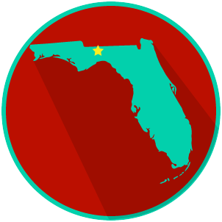
FL State & Local Government: SS.7.C.3.14
State and Local Government Obligations and Services
READING GUIDE #2
Name: ______________________

Date: _______________________

Reading: Grouping Services by Level of Government

Benchmark Clarification 2: Students will classify government services according to level of government in order to evaluate the role that each plays in their lives.

Reading Task | Response
What ideas are presented in the reading?
What is the central idea of the reading?
Select two words or phrases that support the central idea.
How might this reading connect to your own experience or something you have seen, read, or learned before?
Based on what you have read and learned, which level of government do you believe has the most important role in your daily life and why? | The level of government that has the most important role in my daily life is ________________________ because:

