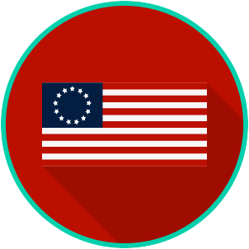
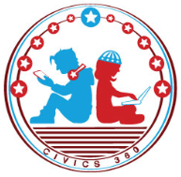
The Founding: SS.7.C.1.1
The Enlightenment and
Its Influence
VIDEO VIEWING GUIDE
Name: ________________________________

Date: _________________________________

Question | List Specific Evidence from the Video | Complete Sentence
1. What were the four areas that philosophers addressed during the Enlightenment?
2. What is the idea of natural law?

3. What is the idea of natural rights?
4. Why can’t government take away your natural rights without cause?
5. How were the Founding Fathers influenced by the idea of natural law and natural rights?
6. According to Locke, what is the social contract?
7. According to Locke, what is the responsibility of government under the social contract?

8. How were the Founding Fathers influenced by the idea of the social contract?

9. What are the three powers of government?
10. According to Montesquieu, why should government powers be separated?
11. How were the Founding Fathers influenced by the idea of separation of powers?

The Founding: SS.7.C.1.1
The Enlightenment and
Its Influence
READING GUIDE #1
Name: ________________________

Date: _________________________

Reading: Important Enlightenment Ideas

Benchmark Clarification 1: Students will identify and describe the Enlightenment ideas of separation of powers, natural law, and social contract.

Reading Task | Response
What ideas are presented in the reading?
What is the central idea of the reading?
Select two words or phrases that support the central idea.
How might this reading connect to your own experience or something you have seen, read, or learned before?
Summarize, in your own words, separation of powers, natural law, and social contract. | Separation of powers can be summarized as:
 | Natural law can be summarized as:
 | Social contract can be summarized as:

The Founding: SS.7.C.1.1
The Enlightenment and
Its Influence
READING GUIDE #2
Name: ________________________

Date: _________________________

Reading: The Enlightenment and the Founding Fathers

Benchmark Clarification 2: Students will examine how Enlightenment ideas influenced the Founders’ beliefs about individual liberties and government.

Reading Task | Response
What ideas are presented in the reading?
What is the central idea of the reading?
Select two words or phrases that support the central idea.
How might this reading connect to your own experience or something you have seen, read, or learned before?
In your own words, what is one way in which Enlightenment ideas influenced the Founders’ beliefs about individual liberties and government? | One way Enlightenment ideas influenced the Founders’ beliefs about individual liberties and government is:

The Founding: SS.7.C.1.1
The Enlightenment and
Its Influence
READING GUIDE #3
Name: ________________________

Date: _________________________

Reading: Montesquieu and Locke

Benchmark Clarification 3: Students will evaluate the influence of Montesquieu’s and Locke’s ideas on the Founding Fathers.

Reading Task | Response
What ideas are presented in the reading?
What is the central idea of the reading?
Select two words or phrases that support the central idea.
How might this reading connect to your own experience or something you have seen, read, or learned before?
How did Montesquieu’s and Locke’s ideas influence the Founding Fathers? | Montesquieu’s and Locke’s ideas influenced the Founding Fathers by:

The Founding: SS.7.C.1.1
The Enlightenment and
Its Influence
VOCABULARY PRACTICE
Name: ________________________

Date: _________________________

The Enlightenment and Its Influence

Write about your understanding of the influence of Enlightenment ideas on the Founding Fathers by explaining the connections between and among each of the terms in the concept circle.

How do the terms in the concept circle fit together?
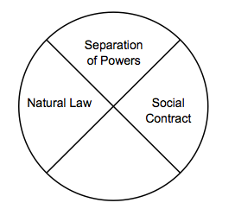

The Founding: SS.7.C.1.1
The Enlightenment and
Its Influence
PRACTICE QUIZ
Name: ________________________

Date: _________________________
The Enlightenment and Its Influence Practice Quiz Reflection

FIRST Attempt Score | I answered ______ questions right.
One thing I learned:

SECOND Attempt Score | I answered ______ questions right.
One thing I learned:

