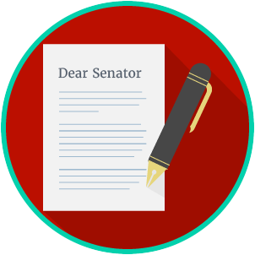
Engaged Citizens: SS.7.CG.2.8
Influencing the Government
VIDEO VIEWING GUIDE
Name: ________________________________

Date: _________________________________

Question | List Specific Evidence from the Video | Complete Sentence
1. What does it mean to ‘influence the government’?

2. Which rights in the First Amendment impact our ability to influence the government?

3. What kinds of media can be used to monitor and influence the government?
4. How does the First Amendment play a role in monitoring and influencing the government?
5. How is the media like a watchdog in monitoring the government?

6. What are three ways that the media can monitor the government?
7. What are four ways that individuals can monitor and influence the government?
8. What is the purpose of an interest group?
9. Describe the relationship between Political Action Committees (PACs) and lobbyists.
10. In what ways do interest groups work to influence the government?
11. What is the impact of individuals, interest groups, and the media on government?

