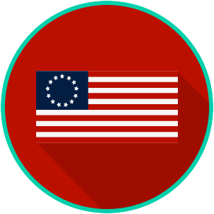
The Founding: SS.7.CG.1.7
Articles of Confederation
VIDEO VIEWING GUIDE
Name: ________________________________

Date: _________________________________

Question | List Specific Evidence from the Video | Complete Sentence
1. What type of system of government was established under the Articles of Confederation?

2. Describe the relationship between states and the central government in a confederal system.

3. Summarize the first three weaknesses of the Articles of Confederation you learned so far.
4. Summarize the weaknesses of the Articles of Confederation.
5. What was Shays’s Rebellion?

6. How did Shays’s Rebellion help lead to the writing of the U.S. Constitution?
7. What occurred at the 1787 Constitutional Convention?

Extra Notes Section

