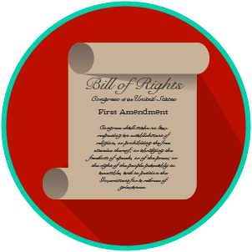
My Rights & Liberties: SS.7.C.3.6
Constitutional Rights and Their Impact
VOCABULARY PRACTICE
Name: _______________________

Date: ________________________

Constitutional Rights and Their Impact

Write about your understanding of constitutional rights by explaining the connections between and among each of the terms in the concept circle.

How do the terms in the concept circle fit together?

