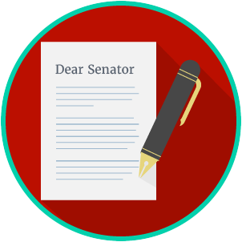
Name: ________________________

Date: _________________________
Engaged Citizens: SS.7.C.2.12
Public Policy
Problem Solving
READING GUIDE #1
Reading: Understanding Levels of Government

Benchmark Clarification 1: Students will identify the appropriate level of government to resolve specific problems.

Reading Task | Response
What ideas are presented in the reading?
What is the central idea of the reading?
Select two words or phrases that support the central idea.
How might this reading connect to your own experience or something you have seen, read, or learned before?
Give one example of a problem that might be solved at local level, one at the state level, and one at the federal level of government. | Local:
 | State:
 | Federal:

