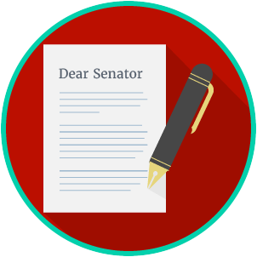
Name: ________________________

Date: _________________________
Engaged Citizens: SS.7.C.2.12
Public Policy
Problem Solving
READING GUIDE #2
Reading: Government Agencies

Benchmark Clarification 2: Students will identify appropriate government agencies to address state or local problems.

Reading Task | Response
What ideas are presented in the reading?
What is the central idea of the reading?
Select two words or phrases that support the central idea.
How might this reading connect to your own experience or something you have seen, read, or learned before?
How do you decide what government agency should address a state or local problem? | You decide what government agency you should ask to help solve a problem by:

