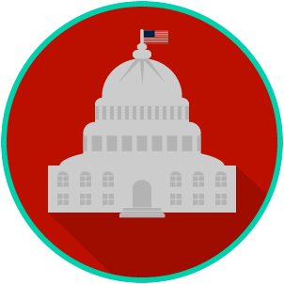
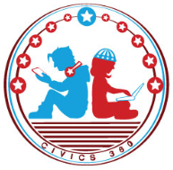
Federal Government: SS.7.C.1.8
Federalists versus
Anti-Federalists
VIDEO VIEWING GUIDE #1
Name: ________________________________

Date: _________________________________

Federalists vs. Anti-Federalists Video #1
Question | List Specific Evidence from the Video | Complete Sentence
1. Which system of government does the United States have as a result of the U.S Constitution?

2. Which system of government did the United States have under the Articles of Confederation?

3. Based on their views, what are the two groups of men that worked to craft the Constitution called?
4. How did the Federalists share their ideas about the Constitution?
5. What did the Federalists believe the new Constitution would do?

6. Which Enlightenment ideas did the Federalists believe would keep the government from getting too powerful?

7. Why did the Federalists oppose a bill of rights?

8. What did the Anti- Federalists believe?

9. How did the Anti- Federalists share their ideas about the Constitution?
10. Why did the Anti- Federalists want a bill of rights?

Federal Government: SS.7.C.1.8
Federalists versus
Anti-Federalists
VIDEO VIEWING GUIDE #2
Name: ________________________________

Date: _________________________________

Federalists vs. Anti-Federalists Video #2
Question | List Specific Evidence from the Video | Complete Sentence
1. What are three things the Federalists and Anti-Federalists disagreed on in the proposed Constitution?
2. What is the purpose of the necessary and proper (or elastic) clause within the Constitution?
3. Why was this clause a concern to the Anti- Federalists?
4. Why did the Anti- Federalists reject the Federalists’ argument about including a bill of rights?
5. How is the ratification of the Constitution an example of a compromise?

Name: ________________________

Date: _________________________
Federal Government: SS.7.C.1.8
Federalists versus
Anti-Federalists
READING GUIDE #1
Reading: Viewpoints on Ratifying the Constitution

Benchmark Clarification 1: Students will identify the viewpoints of the Federalists and the Anti-Federalists about the ratification of the U.S. Constitution.

Reading Task | Response
What ideas are presented in the reading?
What is the central idea of the reading?
Select two words or phrases that support the central idea.
How might this reading connect to your own experience or something you have seen, read, or learned before?
What were the views of the Federalist and Anti-Federalists about the ratification of the U.S. Constitution? | The Federalists believed:
 | The Anti-Federalists believed:

Name: ________________________

Date: _________________________
Federal Government: SS.7.C.1.8
Federalists versus
Anti-Federalists
READING GUIDE #2
Reading: Comparing Viewpoints on Ratifying the Constitution

Benchmark Clarification 2: Students will compare the viewpoints of the Federalists and the Anti-Federalists about the ratification of the U.S. Constitution.

Reading Task | Response
What ideas are presented in the reading?
What is the central idea of the reading?
Select two words or phrases that support the central idea.
How might this reading connect to your own experience or something you have seen, read, or learned before?
In what ways did the Federalists and Anti-Federalists disagree about the U.S. Constitution? | The Federalists and Anti-Federalists disagreed about:

Name: ________________________

Date: _________________________
Federal Government: SS.7.C.1.8
Federalists versus
Anti-Federalists
READING GUIDE #3
Reading: The Anti-Federalists and the Bill of Rights

Benchmark Clarification 3: Students will recognize the Anti-Federalists’ reasons for the inclusion of a bill of rights in the U.S. Constitution.

Reading Task | Response
What ideas are presented in the reading?
What is the central idea of the reading?
Select two words or phrases that support the central idea.
How might this reading connect to your own experience or something you have seen, read, or learned before?
Why did the Anti-Federalists want a Bill of Rights in the U.S. Constitution? | The Anti-Federalists wanted a Bill of Rights in the U.S. Constitution because:

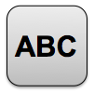
Name: ________________________

Date: _________________________
Federal Government: SS.7.C.1.8
Federalists versus
Anti-Federalists
VOCABULARY PRACTICE
Federalists versus Anti-Federalists

Write about your understanding of the viewpoints of the Federalists and Anti-Federalists by explaining the connections between and among each of the terms in the concept circle.

How do the terms in the concept circle fit together?

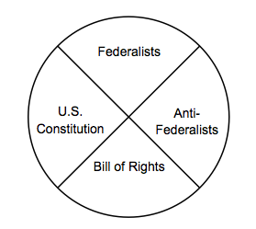

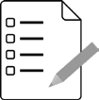
Name: ________________________

Date: _________________________
Federal Government: SS.7.C.1.8
Federalists versus
Anti-Federalists
PRACTICE QUIZ
Federalists versus Anti-Federalists Practice Quiz Reflection

FIRST Attempt Score | I answered ______ questions right.
One thing I learned:

SECOND Attempt Score | I answered ______ questions right.
One thing I learned:

