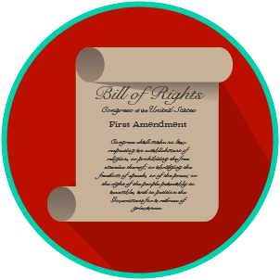
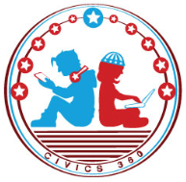
My Rights & Liberties: SS.7.C.2.4
The Bill of Rights and
Other Amendments
VIDEO VIEWING GUIDE #1
Name: ________________________________

Date: _________________________________

The Bill of Rights and the First Amendment Video #1
Question | List Specific Evidence from the Video | Complete Sentence
1. What is an amendment?

2. Why was a bill of rights added to the U.S. Constitution?

3. What are the first ten amendments to the U.S. Constitution called?
4. What are the five freedoms in the First Amendment?
5. How do the five freedoms protect your liberties?

My Rights & Liberties: SS.7.C.2.4
The Bill of Rights and
Other Amendments
VIDEO VIEWING GUIDE #2
Name: ________________________________

Date: _________________________________

The Bill of Rights and Amendments 2-10 Video #2
Question | List Specific Evidence from the Video | Complete Sentence
1. What are the big ideas in the following amendments? | Amendment 2:
 | Amendment 3:
 | Amendment 4:
2. What are the three big ideas in the 5th Amendment?

3. Why is due process an important civil right?
4. How does protection against self- incrimination support the right to due process?
5. What are the big ideas in the following amendments? | Amendment 6:
 | Amendment 7:
 | Amendment 8:
 | Amendment 9:
 | Amendment 10:
6. Why does the 9th Amendment add to constitutional rights and liberties?

Extra Notes Section

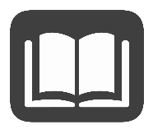
My Rights & Liberties: SS.7.C.2.4
The Bill of Rights and
Other Amendments
READING GUIDE #1
Name: _______________________

Date: ________________________

Reading: The Bill of Rights Comprises the First Ten Amendments

Benchmark Clarification 1: Students will recognize that the Bill of Rights comprises the first ten amendments to the U.S. Constitution.

Reading Task | Response
What ideas are presented in the reading?
What is the central idea of the reading?
Select two words or phrases that support the central idea.
How might this reading connect to your own experience or something you have seen, read, or learned before?
What is the Bill of Rights? | The Bill of Rights is:

My Rights & Liberties: SS.7.C.2.4
The Bill of Rights and
Other Amendments
READING GUIDE #2
Name: _______________________

Date: ________________________

Reading: The Five Freedoms Protected by the First Amendment

Benchmark Clarification 2: Students will recognize the five freedoms protected by the First Amendment.

Reading Task | Response
What ideas are presented in the reading?
What is the central idea of the reading?
Select two words or phrases that support the central idea.
How might this reading connect to your own experience or something you have seen, read, or learned before?
What are the five freedoms protected by the First Amendment? | The five freedoms protected by the First Amendment are:

My Rights & Liberties: SS.7.C.2.4
The Bill of Rights and
Other Amendments
READING GUIDE #3
Name: _______________________

Date: ________________________

Reading: How the Bill of Rights Influences Actions and Interactions

Benchmark Clarification 3: Students will evaluate how the Bill of Rights influences individual actions and social interactions.

Reading Task | Response
What ideas are presented in the reading?
What is the central idea of the reading?
Select two words or phrases that support the central idea.
How might this reading connect to your own experience or something you have seen, read, or learned before?
How does the Bill of Rights influence individual actions and social interactions? | The Bill of Rights influences individual actions and social interactions by:

My Rights & Liberties: SS.7.C.2.4
The Bill of Rights and
Other Amendments
READING GUIDE #4
Name: _______________________

Date: ________________________

Reading: Scenarios that identify rights protected by the Bill of Rights

Benchmark Clarification 4: Students will use scenarios to identify rights protected by the Bill of Rights.

Reading Task | Response
What ideas are presented in the reading?
What is the central idea of the reading?
Select two words or phrases that support the central idea.
How might this reading connect to your own experience or something you have seen, read, or learned before?
Create your own scenario that shows a right protected by the Bill of Rights.

My Rights & Liberties: SS.7.C.2.4
The Bill of Rights and
Other Amendments
READING GUIDE #5
Name: _______________________

Date: ________________________

Reading: Scenarios That Identify Violations of Constitutional Amendments

Benchmark Clarification 5: Students will use scenarios to recognize violations of the Bill of Rights or other constitutional amendments.

Reading Task | Response
What ideas are presented in the reading?
What is the central idea of the reading?
Select two words or phrases that support the central idea.
How might this reading connect to your own experience or something you have seen, read, or learned before?
Create your own scenario that shows a violation of a right listed in the Bill of Rights or another constitutional amendment.

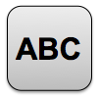
My Rights & Liberties: SS.7.C.2.4
The Bill of Rights and
Other Amendments
VOCABULARY PRACTICE
Name: _______________________

Date: ________________________

The Bill of Rights and Other Amendments

Write about your understanding of constitutional rights by explaining the connections between and among each of the terms in the concept circle.

How do the terms in the concept circle fit together?

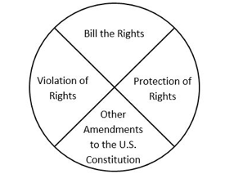

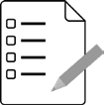
Name: ________________________

Date: _________________________
My Rights & Liberties: SS.7.C.2.4
The Bill of Rights and
Other Amendments
PRACTICE QUIZ
The Bill of Rights and Other Amendments Practice Quiz Reflection

FIRST Attempt Score | I answered ______ questions right.
One thing I learned:

SECOND Attempt Score | I answered ______ questions right.
One thing I learned:

