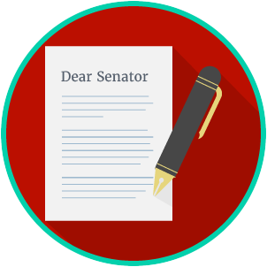
Name: ________________________

Date: _________________________
Engaged Citizens: SS.7.C.2.13
Examining Multiple Perspectives
READING GUIDE #1
Reading: Groups That Influence Public Perspectives

Benchmark Clarification 1: Students will identify groups that influence public perspectives.

Reading Task | Response
What ideas are presented in the reading?
What is the central idea of the reading?
Select two words or phrases that support the central idea.
How might this reading connect to your own experience or something you have seen, read, or learned before?
What are some groups that might influence public perspectives on an issue? | Some groups that might influence public perspectives on an issue are:

