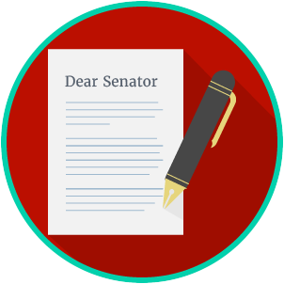
Name: ________________________

Date: _________________________
Engaged Citizens: SS.7.C.2.13
Examining Multiple Perspectives
READING GUIDE #2
Reading: Scenarios on Perspectives

Benchmark Clarification 2: Students will use scenarios to understand the reaction or perspective of different groups.

Reading Task | Response
What ideas are presented in the reading?
What is the central idea of the reading?
Select two words or phrases that support the central idea.
How might this reading connect to your own experience or something you have seen, read, or learned before?
Create your own scenario that compares how two groups might have different perspectives on an issue.

