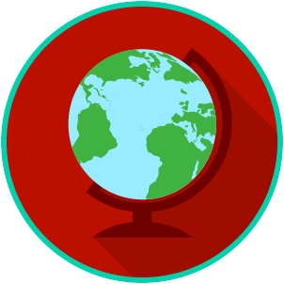
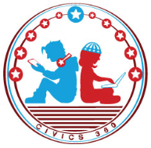
The U.S. & The World: SS.7.C.3.2
Systems of Government
VIDEO VIEWING GUIDE
Name: ________________________________

Date: _________________________________

Question | List Specific Evidence from the Video | Complete Sentence
1. What are the three powers all forms of government have?

2. Where is the power in a parliamentary system of government?
3. Who do citizens vote for in a parliamentary system?
4. Who is the leader in a parliamentary system of government?
5. What “body” of government holds most of the power in a parliamentary system of government?
6. In a federal system of government, how is power shared?
7. In a confederal system of government, where is the power held?
8. Who usually holds most of the power in a unitary system of government?
9. What is the relationship between the national government and the states in a unitary system of government?

Practice: Identify the System of Government for each scenario.
Scenario | Which system of government is being described?
Scenario 1: The power of government is held with the legislative body, with a Prime Minister in charge.
Scenario 2: There is no central power of government, instead government power is held with at the lower government unit level, such as a state.
Scenario 3: The power of government is shared between the central (national) government and the states.
Scenario 4: Government power is held with the central (national) government.

Name: ________________________

Date: _________________________
The U.S. & The World: SS.7.C.3.2
Systems of Government
READING GUIDE #1
Reading: Defining Systems of Government

Benchmark Clarification 1: Students will define parliamentary, federal, confederal, and unitary systems of government.

Reading Task |  | Response
What ideas are presented in the reading?
What is the central idea of the reading?
Select two words or phrases that support the central idea.
How might this reading connect to your own experience or something you have seen, read, or learned before?
Define in your own words the systems of government you learned about.
Parliamentary:

Federal:

Confederal:

Unitary:

Name: ________________________

Date: _________________________
The U.S. & The World: SS.7.C.3.2
Systems of Government
READING GUIDE #2
Reading: Comparing Systems of Government

Benchmark Clarification 2: Students will compare the organizational structures of systems of government.

Reading Task | Response
What ideas are presented in the reading?
What is the central idea of the reading?
Select two words or phrases that support the central idea.
How might this reading connect to your own experience or something you have seen, read, or learned before?
Create a chart that shows the organizational structure of each of the systems of government you learned (parliamentary, federal, confederal, unitary). Use extra paper or the other side of this page if necessary.

Name: ________________________

Date: _________________________
The U.S. & The World: SS.7.C.3.2
Systems of Government
READING GUIDE #3
Reading: Identifying Examples of Systems of Government

Benchmark Clarification 3: Students will recognize examples of these systems of government.

Reading Task |  | Response
What ideas are presented in the reading?
What is the central idea of the reading?
Select two words or phrases that support the central idea.
How might this reading connect to your own experience or something you have seen, read, or learned before?
Give an example of each of the systems of government you learned about. Be sure to explain the example.
Parliamentary:

Federal:

Confederal:

Unitary:

Name: ________________________

Date: _________________________
The U.S. & The World: SS.7.C.3.2
Systems of Government
READING GUIDE #4
Reading: Systems of Government Scenarios

Benchmark Clarification 4: Students will analyze scenarios describing various systems of government.

Reading Task | Response
What ideas are presented in the reading?
What is the central idea of the reading?
Select two words or phrases that support the central idea.
How might this reading connect to your own experience or something you have seen, read, or learned before?
Create a scenario of your own that describes one of the systems of government you learned about (parliamentary, federal, confederal, or unitary).

The U.S. and The World: SS.7.C.3.2
Systems of Government
VOCABULARY PRACTICE
Name: _______________________

Date: ________________________

Systems of Government

Write about your understanding of the different systems of government by explaining the connections between and among each of the terms in the concept circle.

How do the terms in the concept circle fit together?

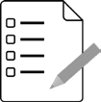
Name: ________________________

Date: _________________________
The U.S. & The World: SS.7.C.3.2
Systems of Government
PRACTICE QUIZ
Systems of Government Practice Quiz Reflection

FIRST Attempt Score | I answered ______ questions right.
One thing I learned:

SECOND Attempt Score | I answered ______ questions right.
One thing I learned:

