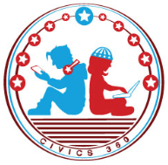
The Founding: SS.7.CG.1.5
The Road to Independence
VIDEO VIEWING GUIDE #5
Name: ________________________________

Date: _________________________________
Complaints Against the King and Parliament Video #5
Question | List Specific Evidence from the Video | Complete Sentence
1. List two acts that helped lead to the Declaration of Independence.
2. Explain how the individual rights of colonists were limited.

3. How was representation a problem for the colonies?
4. What was the problem with taxation for the colonies?
5. What are the three main themes of the colonists’ complaints and their reason for writing the Declaration of Independence?

