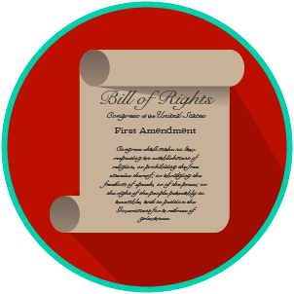
Name: _______________________

Date: ________________________
My Rights & Liberties: SS.7.C.3.7
Voting Rights
READING GUIDE #1

Reading: Voting Rights

Benchmark Clarification 1: Students will recognize the rights outlined in these amendments.

Reading Task | Response
What ideas are presented in the reading?
What is the central idea of the reading?
Select two words or phrases that support the central idea.
How might this reading connect to your own experience or something you have seen, read, or learned before?
List the rights outlined in the 13th, 14th, 15th, 19th, 24th, and 26th Amendments. | 13th Amendment:
 | 14th Amendment:
 | 15th Amendment:
 | 19th Amendment:
 | 24th Amendment:
 | 26th Amendment:

