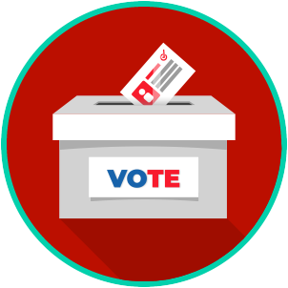
Voting and Elections: SS.7.CG.2.6
Election Processes
READING GUIDE #3
Name: ____________________

Date: _____________________
Reading: Elections and Voting

Benchmark Clarification 3: Students will explain how free and fair elections promote trust in democratic institutions and preserve the republic.

Reading Task | Response
What ideas are presented in the reading?
What is the central idea of the reading?
Select two words or phrases that support the central idea.
How might this reading connect to your own experience or something you have seen, read, or learned before?
Discuss two obstacle that must be addressed to ensure free and fair elections.

